**Selenium WebDriver Installation and Script Run:**

Selenium WebDriver installation is divided in to simple steps to get & learn how to Install & configure WebDriver to kick of your automation testing.

**Step 1: Download & Install Java on your Computer**

Before start working with the Learn Selenium WebDriver, we will need the first download **Java Development Kit (JDK)**.

Here you can download [**Java Development Kit (JDK).**](http://www.oracle.com/technetwork/java/javase/downloads/index.html)

<http://www.oracle.com/technetwork/java/javase/downloads/jdk8-downloads-2133151.html>

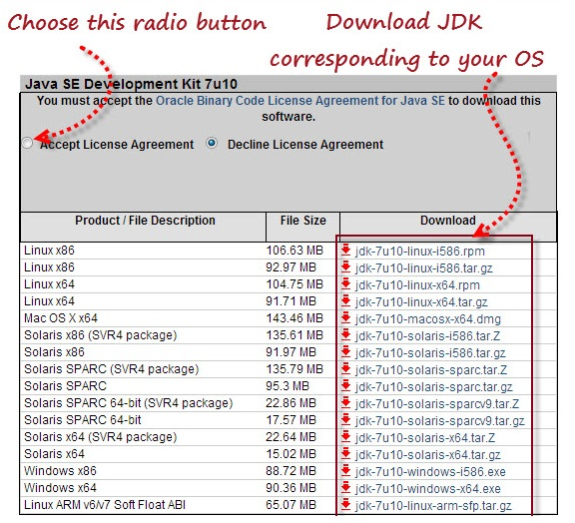

NOTE: Got cmd run and type **java –version**

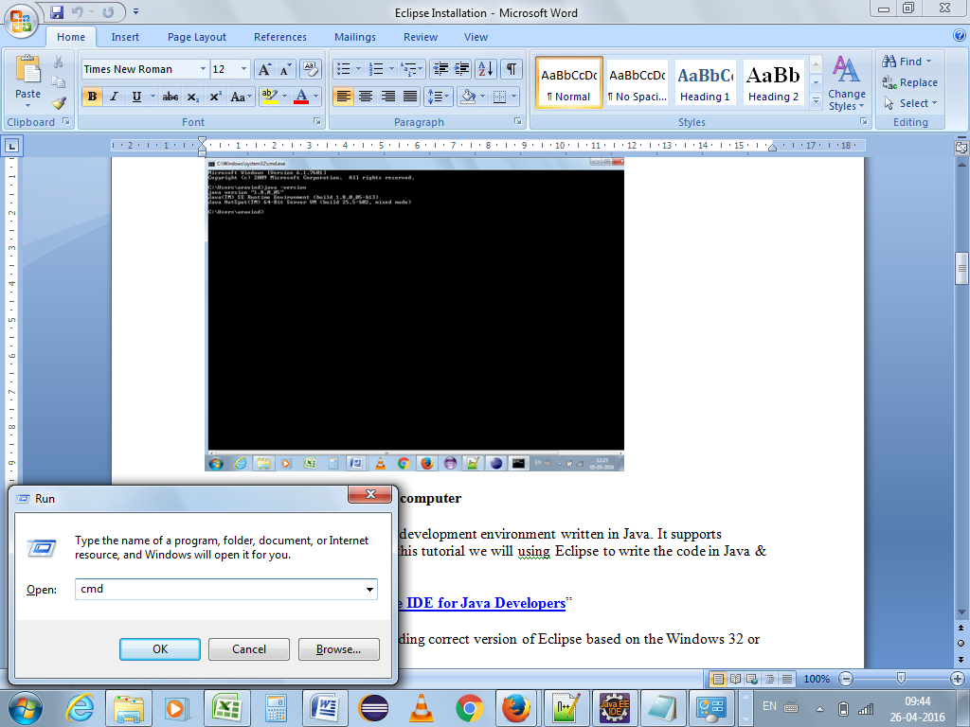

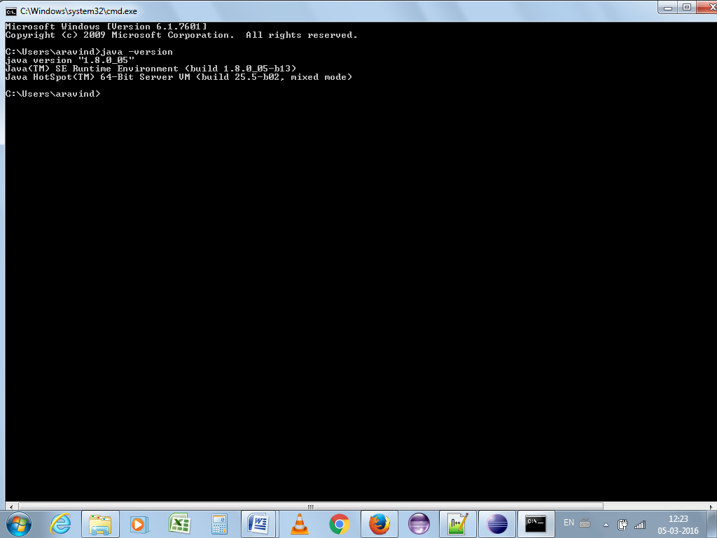

**Link to Install JDK and JRE:**

**<http://www.oracle.com/technetwork/java/javase/downloads/jdk8-downloads-2133151.html>** 🡪 JDK Download link  
[**http://www.oracle.com/technetwork/java/javase/downloads/jre8-downloads-2133155.html**](http://www.oracle.com/technetwork/java/javase/downloads/jre8-downloads-2133155.html) 🡪 JRE Download link

**Step 2: Install Eclipse on your computer**

**Eclipse** is open source software development environment written in Java. It supports supports multiple languages. In this tutorial we will using Eclipse to write the code in Java & execute your first test script.

Here you can download “[**Eclipse IDE for Java Developers**](http://www.eclipse.org/downloads/)”

Make sure that you are downloading correct version of Eclipse based on the Windows 32 or 64 bit version.

[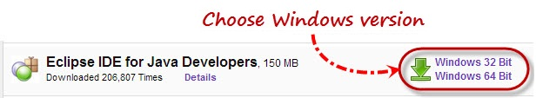](http://www.softwaretestingclass.com/wp-content/uploads/2013/03/download-eclipse-ide-for-java-developers.jpg)

Download “Eclipse IDE” for Java Developers

Once you select the windows version based on your requirement, you should be able to download a “**eclipse-java-juno-SR2-win32-x86_64.zip**” ZIP file.

Once you successfully download the ZIP file, extract the ZIP file in your PC.

For Eclipse, you do not need any installation; just double click on “eclipse.exe” file in the extracted ZIP folder.

**NOTE Latest Link:**

[*https://www.eclipse.org/downloads/download.php?file=/technology/epp/downloads/release/mars/2/eclipse-jee-mars-2-win32.zip*](https://www.eclipse.org/downloads/download.php?file=/technology/epp/downloads/release/mars/2/eclipse-jee-mars-2-win32.zip)

[*https://eclipse.org/downloads/download.php?file=/technology/epp/downloads/release/mars/2/eclipse-jee-mars-2-win32-x86_64.zip*](https://eclipse.org/downloads/download.php?file=/technology/epp/downloads/release/mars/2/eclipse-jee-mars-2-win32-x86_64.zip)

*https://eclipse.org/downloads/*

**Step 3: Download Selenium Java Client Driver**

Selenium client driver is available in the different languages like Java, C#, Ruby, Python etc. But in this article we are concentrating on Java language.

Here you can download “[**Selenium Java Client Driver**](http://seleniumhq.org/download/)”

**Link:**  [*http://docs.seleniumhq.org/download/*](%20http:/docs.seleniumhq.org/download/)

[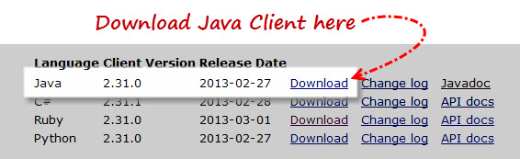](http://www.softwaretestingclass.com/wp-content/uploads/2013/03/download-selenium-java-client-driver.jpg)

Download “Selenium Java Client Driver”

Once you click on Download link for Java client then you should be able to download a “**selenium-java-2.31.0.zip**” ZIP file.

Once you successfully download the ZIP file, extract the ZIP file in your PC in the directory “C:\selenium- java-2.31.0”. You will see JARs files in extracted folder which would be imported in to Eclipse before running our first Selenium WebDriver script.

**Previous Release Download:**

Click ” Previous Releases”

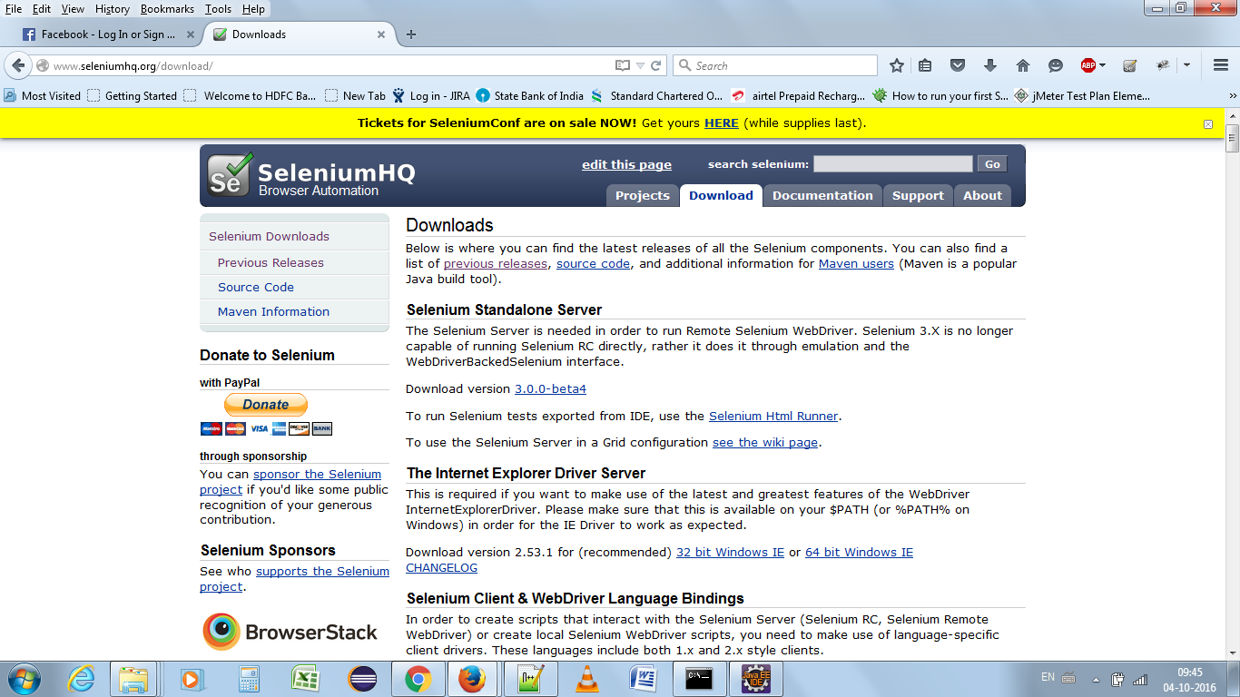

Click version 2.53

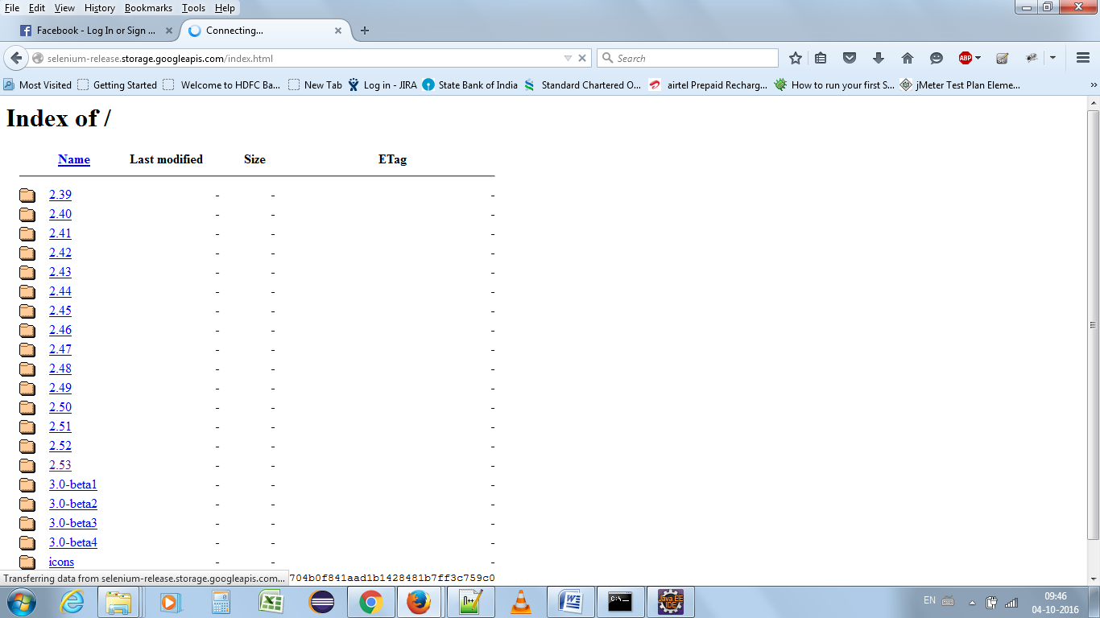

**Click on** [selenium-java-2.53.1.zip](http://selenium-release.storage.googleapis.com/2.53/selenium-java-2.53.1.zip),

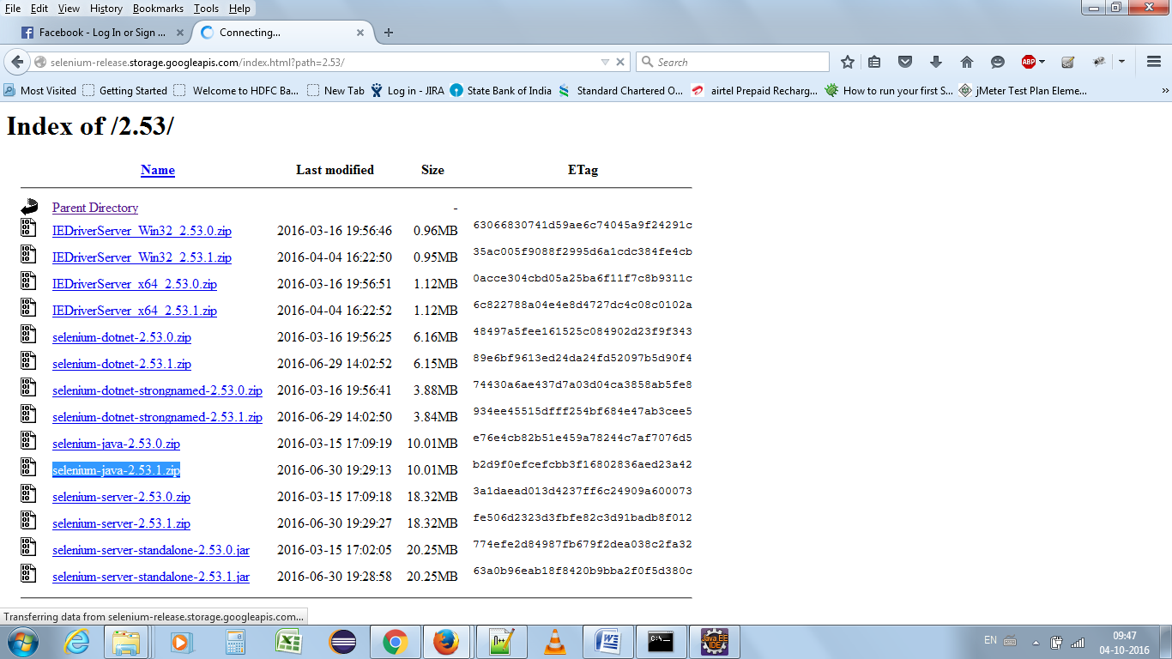

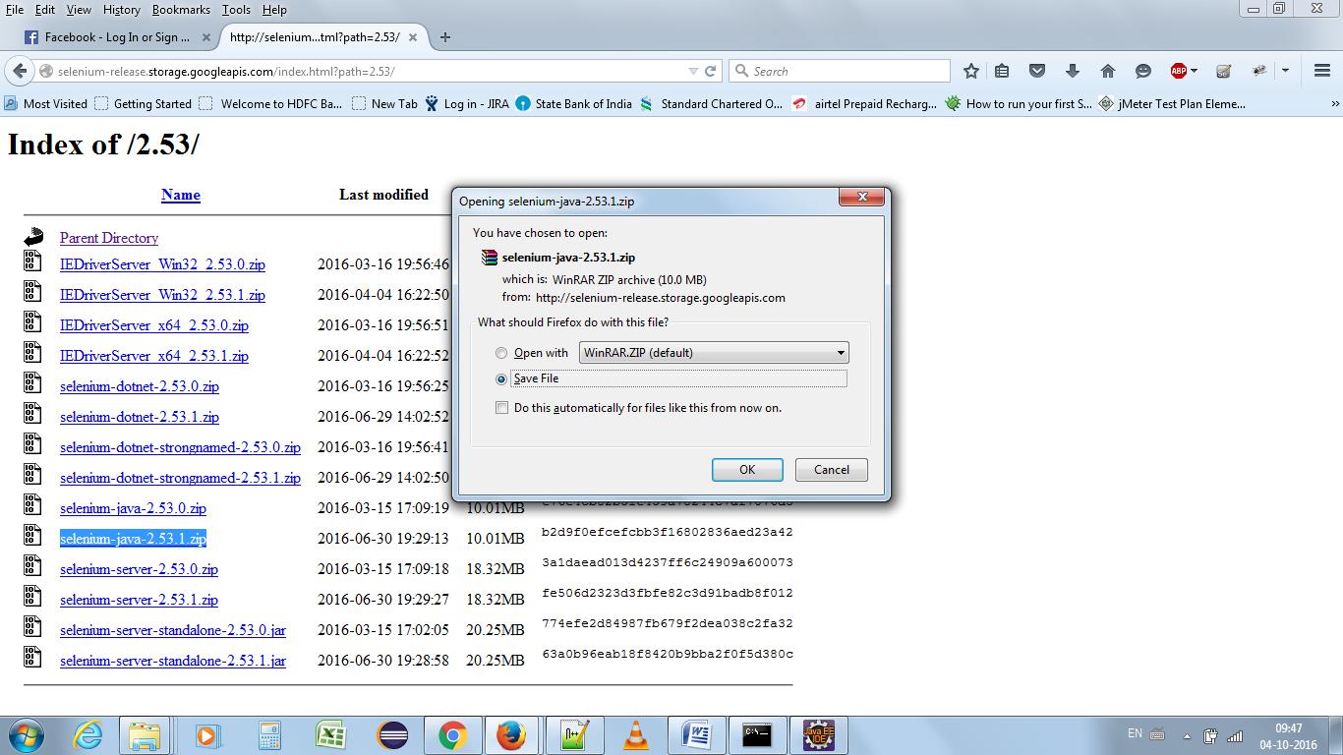

**Step 4: Configure Eclipse with Selenium WebDriver**

In Step 2 we have installed Eclipse, just Launch the “eclipse.exe” file from the extracted Eclipse folder.

Once you open the “eclipse.exe” file then it will ask you to select the workspace, here you can select the path where you want to save Eclipse project.

[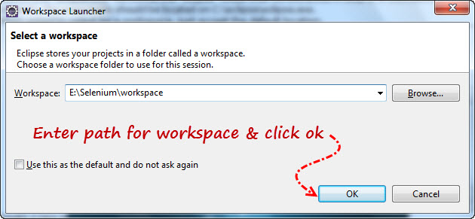](http://www.softwaretestingclass.com/wp-content/uploads/2013/03/selenium-webdriver-workspace-eclipse-project.jpg)

Selenium WebDriver workspace in eclipse

First step is to create a Java Project:

* Go to File menu > New > Java Project.
* Enter Project Name as “Selenium_webdriver_project”
* Click on Finish button.

[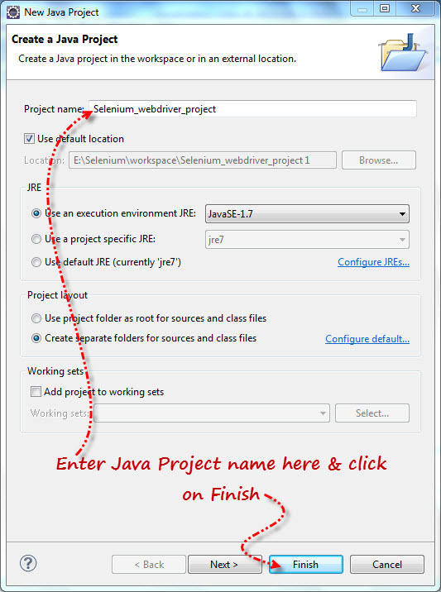](http://www.softwaretestingclass.com/wp-content/uploads/2013/03/create-java-project.jpg)

Create Java Project – Selenium WebDriver

Second step is to create a Class under Java project:

* Under newly created project “Selenium_webdriver_project” you will see the “src“ folder & right click on the “src” folder & create the new class as “Webdriver_class”.

[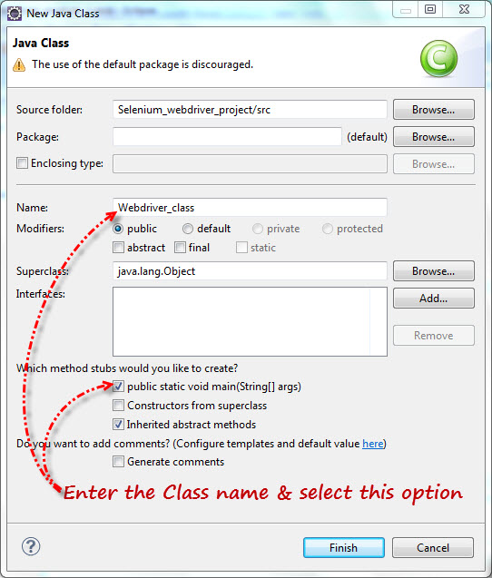](http://www.softwaretestingclass.com/wp-content/uploads/2013/03/create-java-class.jpg)

Create Java Class – Selenium WebDriver

Once you created the class you will see the Eclipse screen like this.

[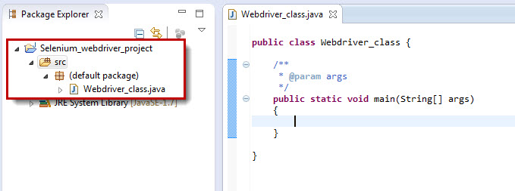](http://www.softwaretestingclass.com/wp-content/uploads/2013/03/start-with-eclipse.jpg)

Start with Eclipse

* Right click on “Selenium_webdriver_project” & select Properties option.
* Select “Java Build Path” option in the left side of the Properties dialog box.
* Click on Libraries tab
* Click on “Add External JARs..” button.
* Select the extracted Selenium Java Client Driver folder downloaded in Step3 & add all JAR files present in the inside & outside of the “libs” folder. Once you select these JAR files then your properties folder will look like as below.

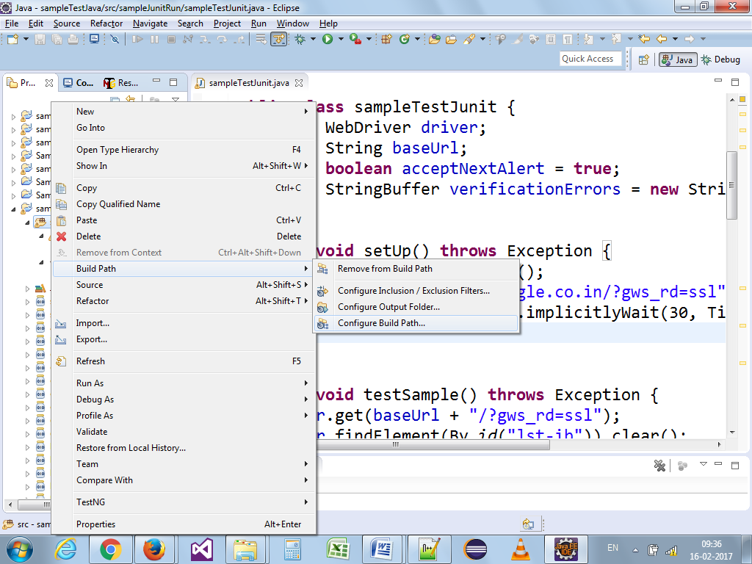

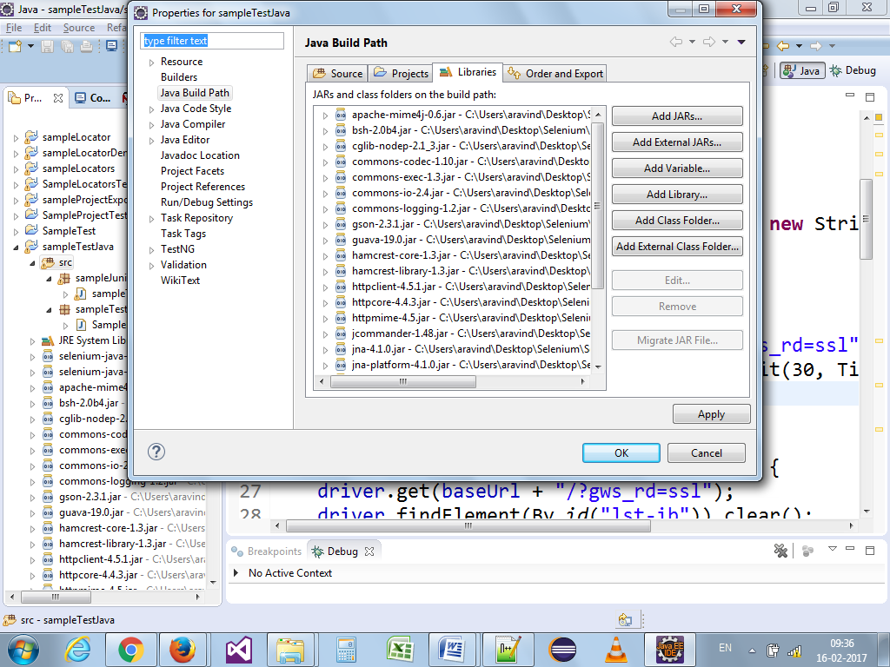

[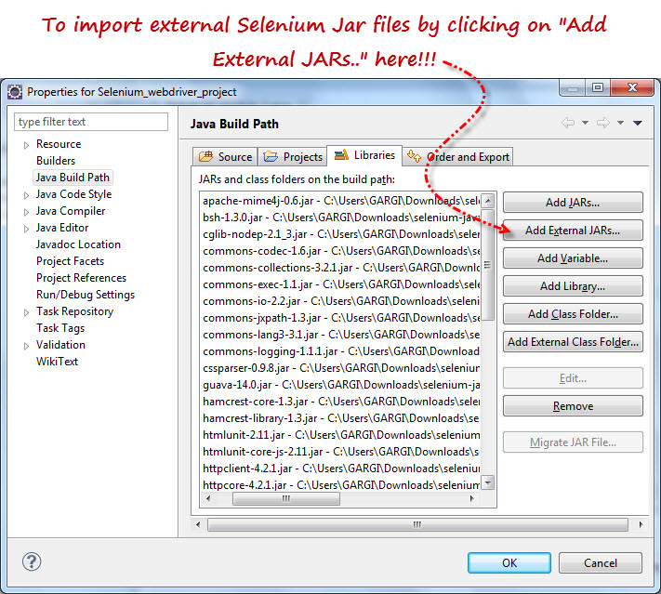](http://www.softwaretestingclass.com/wp-content/uploads/2013/03/import-external-selenium-client-jar-files.jpg)

Import External- Selenium Client JAR Files

* Click on OK in the Properties dialog box to import.

**Step 5:** **Run your first Selenium WebDriver script.**

import org.openqa.selenium.WebDriver;

import org.openqa.selenium.firefox.FirefoxDriver;

public class Webdriver_class

{

public static void main(String[] args)

{

WebDriver driver = new FirefoxDriver();

driver.get("http://google.com");

System.out.println(driver.getTitle());

driver.close();

}

}

**Environment variable setting:**

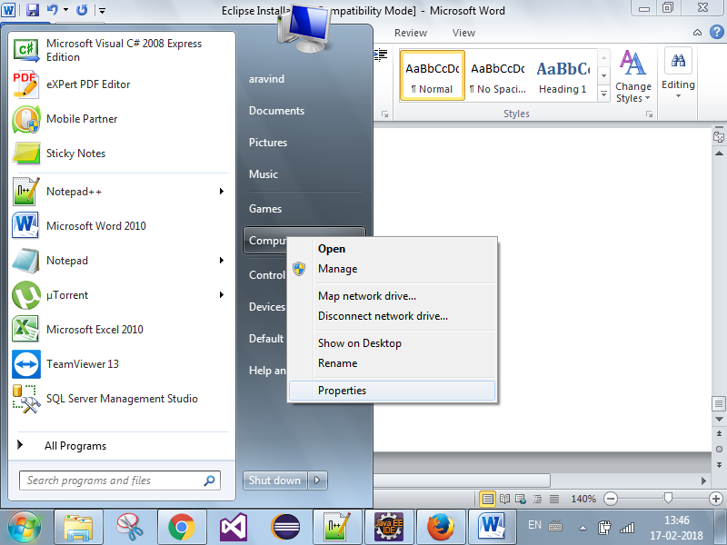

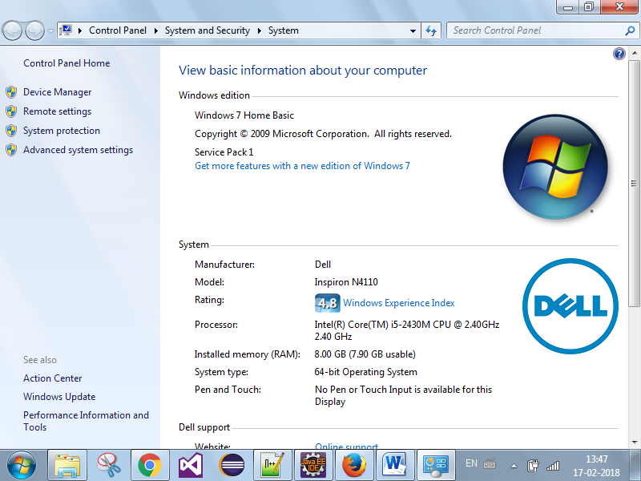

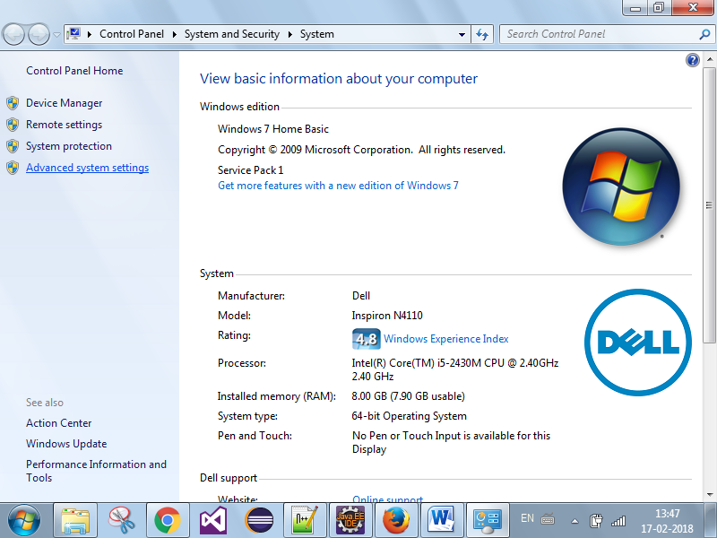

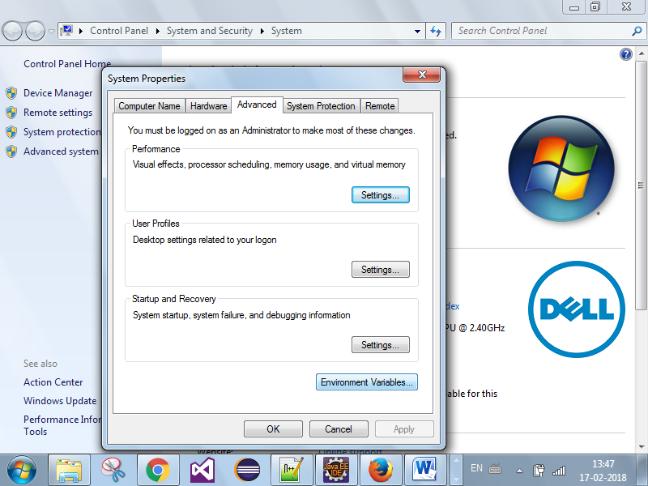

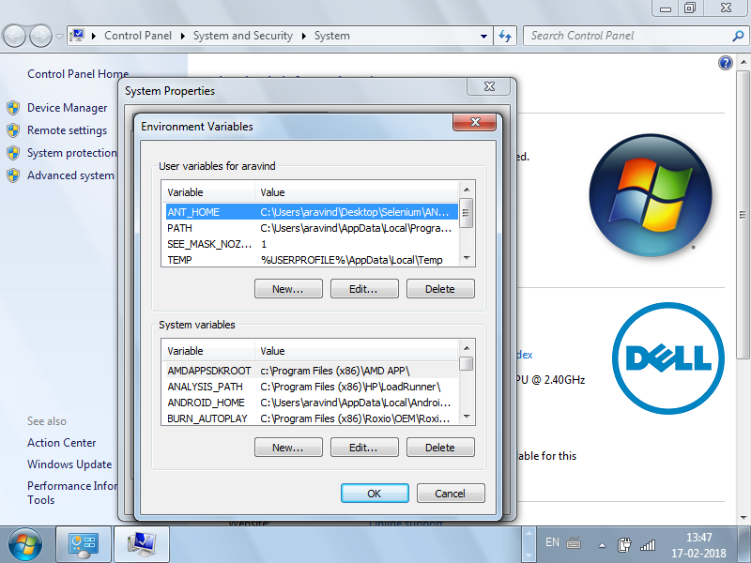

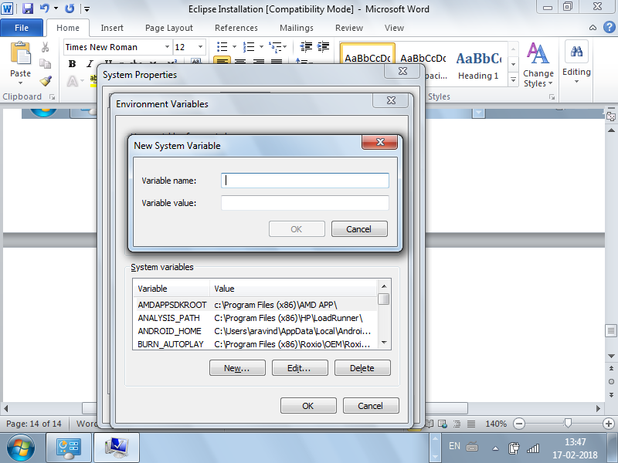

Variable name : JAVA_HOME

Variable value : path of the jdk(C:\Program Files\Java\jdk1.8.0_25)

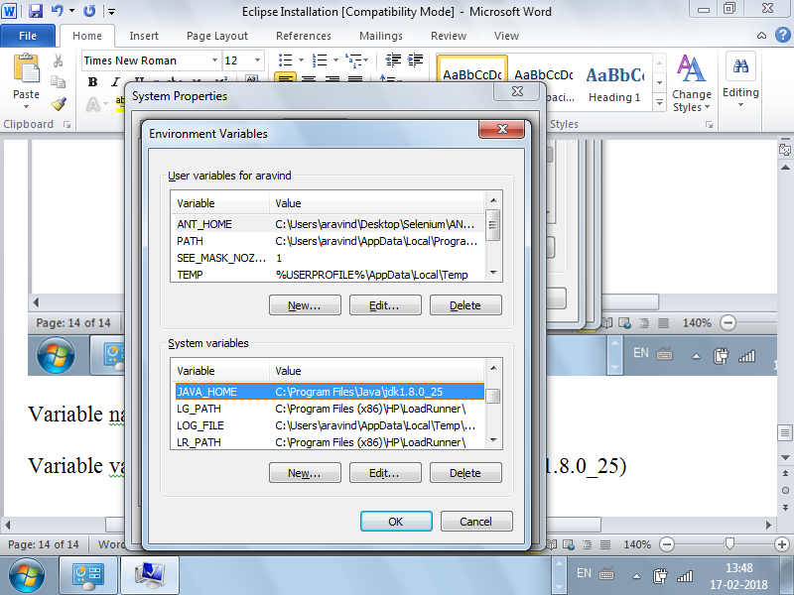

Next we need to set the path of jdk bin libraries

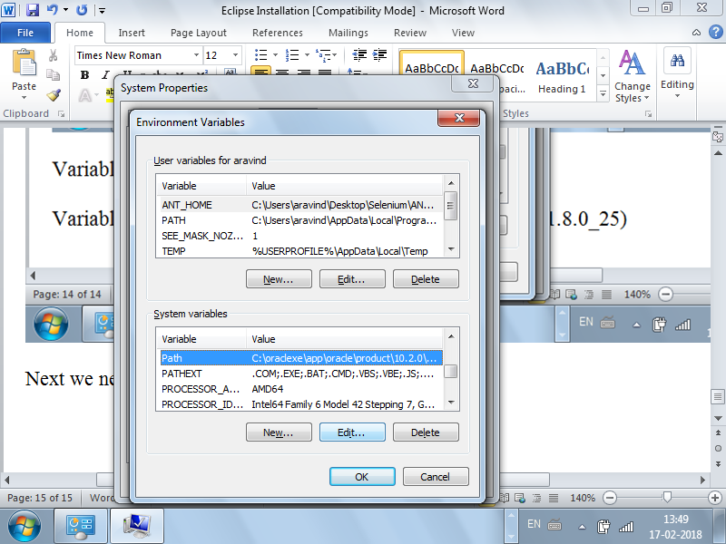

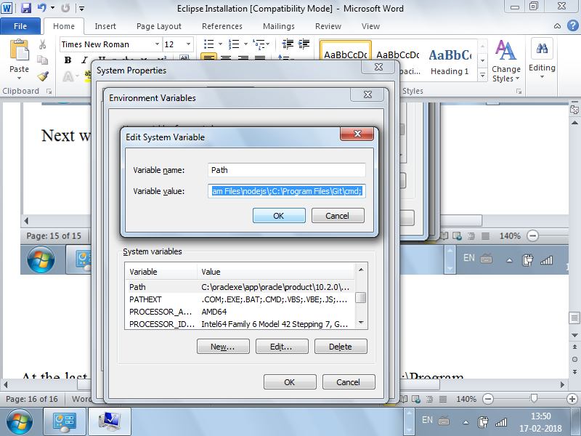

At the last give a “;” and provide the path of the jdk bin (C:\Program Files\Java\jdk1.8.0_25\bin) and click on “ok”